Attaching a File to Your Proposal

Follow the steps below to upload a file to your proposal including your paper.

- Login to MemberLeap using the following URL
https://mms.pnsqc.org/members/proposals/propselect.php?orgcode=PNSQ&prid=1013939

- Click on Access Existing Proposal:
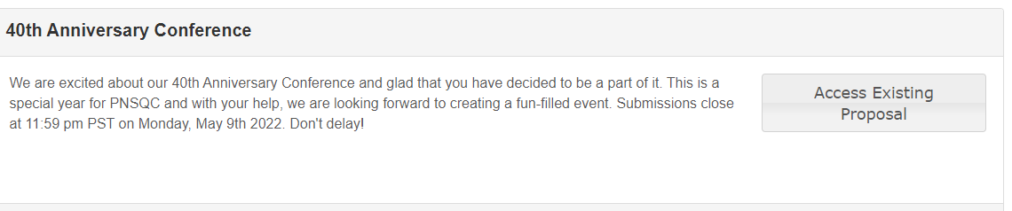

You will see the following screen

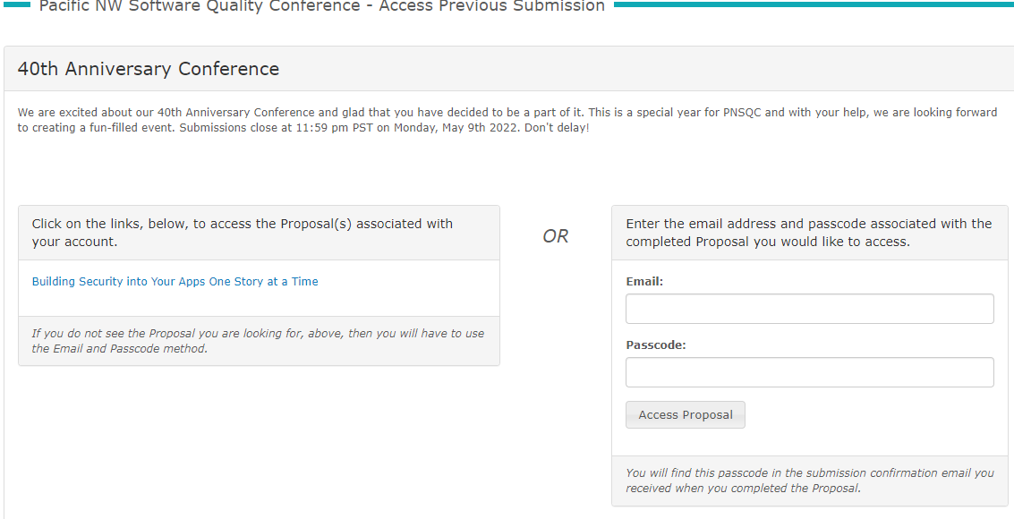

If you do not see your proposal, provide the email and the Passcode. A passcode was assigned to you when you submitted the proposal. You will see your original proposal.

- Click on Access Proposal
You will see your original proposal

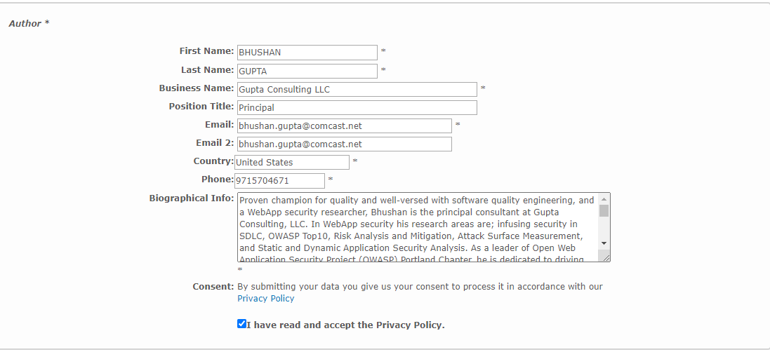

Make sure you check the Privacy Policy box.

- Click on the proposal Tab
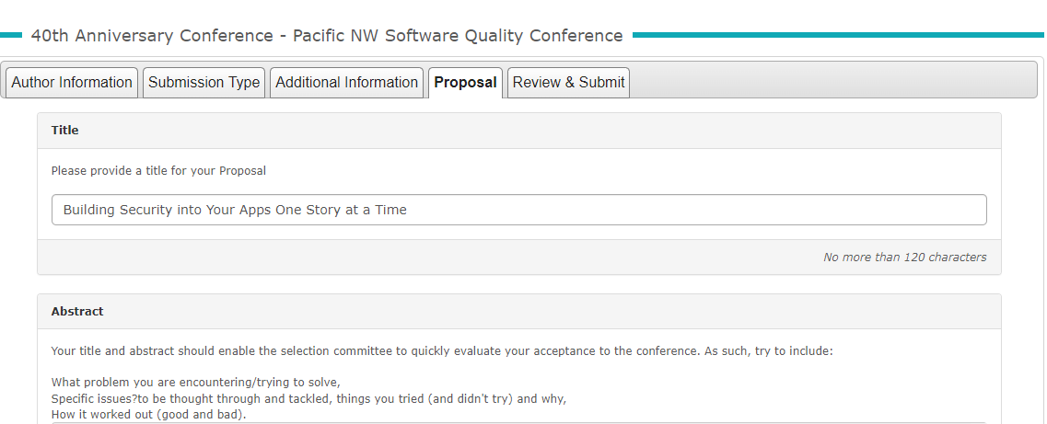

- Scroll down to Submit Proposal File

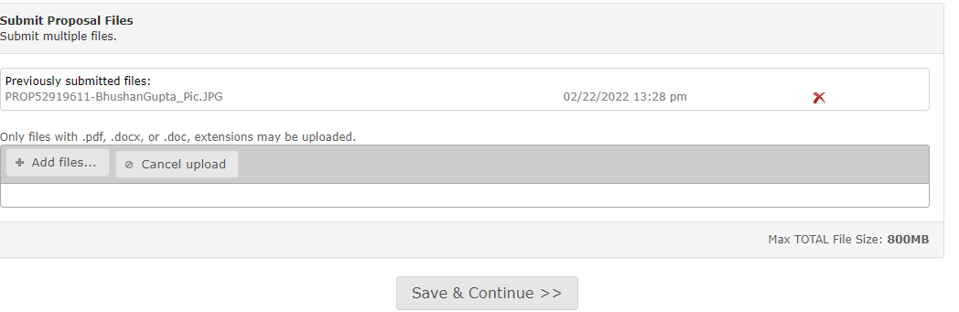
- Click on Add Files and Select a file from your source.
Make sure file name includes your name (primary author)

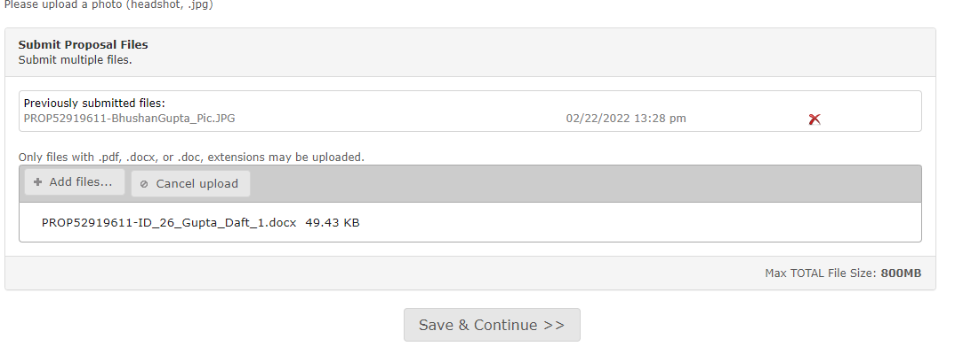

- Save and continue.

Your file will be listed under submitted files.
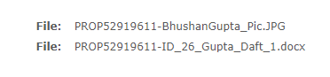
This will conclude your process.

